**Exercise 1: Control Structures**

**Scenario 1:** The bank wants to apply a discount to loan interest rates for customers above 60 years old.

* + **Question:** Write a PL/SQL block that loops through all customers, checks their age, and if they are above 60, apply a 1% discount to their current loan interest rates.

**Answer :**

BEGIN

FOR cust_rec IN (SELECT CustomerID, DOB FROM Customers) LOOP

IF (TRUNC(MONTHS_BETWEEN(SYSDATE, cust_rec.DOB) / 12) > 60) THEN

UPDATE Loans

SET InterestRate = InterestRate - 1

WHERE CustomerID = cust_rec.CustomerID;

END IF;

END LOOP;

COMMIT;

END;

/

**OUTPUT:**

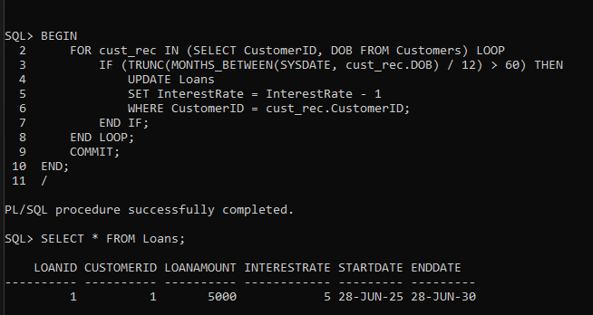

**Scenario 2:** A customer can be promoted to VIP status based on their balance.

* + **Question:** Write a PL/SQL block that iterates through all customers and sets a flag IsVIP to TRUE for those with a balance over $10,000.

**Answer :**

**Step 1:** ALTER TABLE Customers ADD (IsVIP CHAR(1));

**Step 2:**

BEGIN

FOR cust_rec IN (SELECT CustomerID, Balance FROM Customers) LOOP

IF cust_rec.Balance > 10000 THEN

UPDATE Customers

SET IsVIP = 'Y'

WHERE CustomerID = cust_rec.CustomerID;

ELSE

UPDATE Customers

SET IsVIP = 'N'

WHERE CustomerID = cust_rec.CustomerID;

END IF;

END LOOP;

COMMIT;

END;

/

**OUTPUT:**

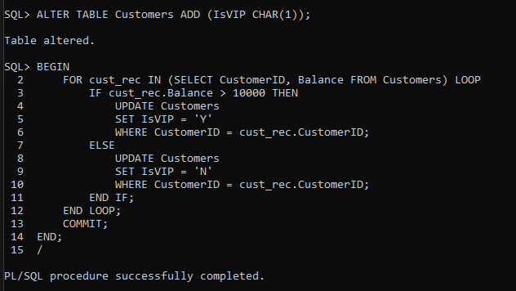

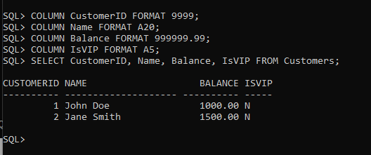

**Scenario 3:** The bank wants to send reminders to customers whose loans are due within the next 30 days.

**Question:** Write a PL/SQL block that fetches all loans due in the next 30 days and prints a reminder message for each customer

**Answer:**SET SERVEROUTPUT ON;

BEGIN

FOR loan_rec IN (

SELECT LoanID, CustomerID, EndDate

FROM Loans

WHERE EndDate <= SYSDATE + 30

) LOOP

DECLARE

cust_name VARCHAR2(100);

BEGIN

SELECT Name INTO cust_name

FROM Customers

WHERE CustomerID = loan_rec.CustomerID;

DBMS_OUTPUT.PUT_LINE(

'Reminder: Loan ' || loan_rec.LoanID ||

' for ' || cust_name ||

' is due on ' || TO_CHAR(loan_rec.EndDate, 'DD-MON-YYYY')

);

END;

END LOOP;

END;

/

**OUTPUT:**

